THE UNIVERSITY OF DODOMA

COLLAGE OF INFORMATICS AND VIRTUAL EDUCATION
DEPARTMENT OF COMPUTER SCIENCE AND ENGINEERING
GROUP ASSIGNMENT
GROUP NUMBER | : | 14
MODULE NAME | : | ROBOTICS
MODULE CODE | : | CT 322
SEMESTER | : | TWO
ACADEMIC YEAR | : | 2025 / 2026
PARTICIPANTS
S/N | NAME | REG NUMBER
1 | HASSAN MWAKIPESILE | T22-03-09904
2 | NYEMO ROBERT | T22-03-05289
3 | VICTOR THADEUS | T22-03-11768
4 | AUGUSTINO AUGUSTINO | T22-03-04045

2. Introduction:
This report presents the structural inspection, kinematic analysis, and motion demonstration of a robot CAD assembly, completed as part of the CAD-Based Robot Structure Identification and Motion Demonstration assignment. The purpose of this exercise is to interpret a downloaded robot CAD model as a practical robotics system composed of a base, links, joints, moving parts, and an end-effector, and to demonstrate a simple pick-and-place motion using MATLAB and Robotics System Toolbox.
The selected model was inspected in SolidWorks (source format) and re-verified independently in Onshape, then imported into MATLAB via a URDF export for kinematic simulation. Two independent inspection methods — manual mate inspection in Onshape and direct parsing of the exported Simscape/URDF joint structure — were used to cross-check the robot's true degrees of freedom, which is discussed in detail in Section 5.
3. Selected Robot ZIP File:
Item | Detail
Selected ZIP file | robotic-arm-3-dof-pick-and-place-mechanism-1.snapshot.1.zip
Likely robot type | 3-DOF robotic arm (pick-and-place mechanism)
CAD authoring tool | SolidWorks (assembly + parts), re-verified in Onshape
Number of part files | 5 (.SLDPRT) + 1 main assembly (.SLDASM)

4. CAD Assembly Inspection:
The ZIP archive was extracted and opened as an assembly. The main assembly file and its five linked part files were identified as follows:
File Name | Type | Description
Assemblage1 first bras.SLDASM | Main assembly | Contains the complete robot model and all mate relationships

Full Assembly View
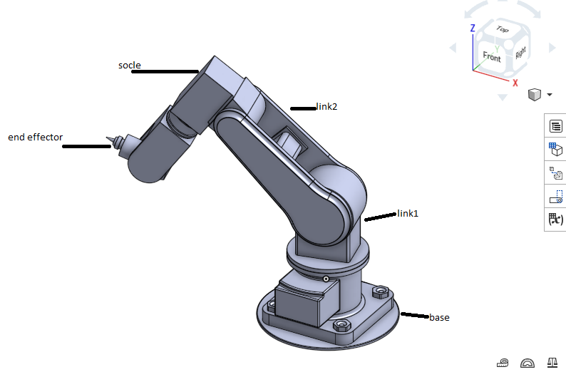
Robot view from Onshape

Labelled Parts
The screenshort below show the bas part of pick and place robotic arm . Each part was verified individually by selecting it in the Onshape
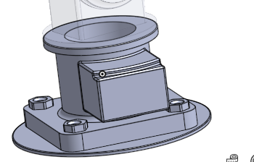
Base (Piece1) highlighted
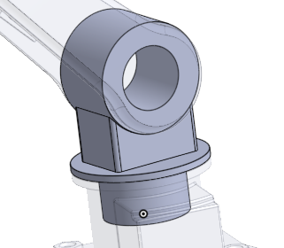
Link 1 (piece 2) highlighted
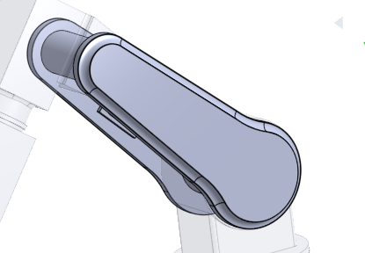
Link 2 (Piece 3) highlighted
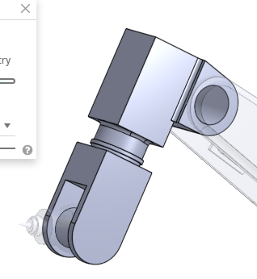
Socle / wrist mount (piece 4) highlighted
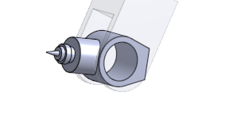
End-effector (piece 5) highlighted
Mechanical Assembly Description
The robot is mechanically assembled as a serial chain. The base plate provides a fixed mounting point. Link 1 is rigidly attached to the base with no relative motion between them. From Link 1, three sequential revolute joints allow Link 2, the socle/wrist segment, and the end-effector to each rotate relative to the part before it, producing the overall arm motion used for pick-and-place tasks. No separate motors or actuators were visible as distinct CAD bodies; actuation is assumed to occur at each revolute joint location.
The original ZIP file contained zero pre-defined mates (0 Mate features) when opened in Onshape, meaning the parts were positioned visually but not mechanically constrained. Mates were added manually in Onshape, and the joint structure was subsequently re-verified against an independent Simscape/URDF export.
5. Robot Type and DOF Identification
Item | Description
Selected ZIP file | robotic-arm-3-dof-pick-and-place-mechanism-1.snapshot.1.zip
Robot type | Articulated robot arm (serial revolute-jointed manipulator)
Estimated DOF | 3 (three independent revolute joints)
Main application | Pick-and-place
Reason for classification | The assembly contains 5 rigid bodies connected by one fixed joint (base:Link 1) and three revolute joints in series (Link 1–Link 2, Link 2–socle, socle–end-effector). This was confirmed two independent ways: (1) manually created mates in Onshape showed 4 rotational connections initially, and (2) parsing the model's exported Simscape (.slx) and URDF joint definitions directly showed only 3 of those connections are true revolute joints, the base-to-Link 1 connection is a Weld/Fixed joint with zero motion. The second, file-level method is authoritative, giving a final DOF count of 3, which also matches the original ZIP file's own name.

6. Link and Joint Identification:
The table below lists the confirmed joints of the robot, cross-verified from the exported Simscape (.slx) block wiring and the imported URDF's rigidBodyTree structure in MATLAB (both independently produced identical results).
Joint | Connected Parts | Joint Type | Motion Description | Axis
— | Base (Piece1) :Link 1 (piece 2) | Fixed (Weld) | No relative motion; Link 1 is rigidly mounted to the base | N/A
Joint 1 | Link 1 (piece 2) :Link 2 (Pièce 3) | Revolute | Raises/lowers Link 2 relative to Link 1 (shoulder-type motion) | Horizontal, perpendicular to the base plate
Joint 2 | Link 2 (Pièce 3) : Socle (piece 4) | Revolute | Bends the arm at the elbow/wrist mount | Horizontal, parallel to Joint 1
Joint 3 | Socle (piece 4) : End-effector (piece 5) | Revolute | Orients the end-effector tip toward the target | Axis along the tool direction
A revolute joint allows rotation about a single axis; a fixed (weld) joint permits no relative motion between the two connected bodies. With only 3 revolute joints in series and no prismatic (sliding) or gripper joints present, the robot is correctly classified as a 3-DOF articulated arm.
7. Robot Motion Reference Points
Reference Point | Description | Robot Condition
Home position | Starting position of the robot | All 3 joints at 0°
Object position | Position where the robot reaches the object | Joint 1 and 2 rotated toward target, end-effector above object
Pick position | Position where the robot picks the object | End-effector lowered/oriented onto the object
Place position | Position where the robot moves the object | Joints rotated to bring end-effector above the destination
Final position | End of the movement | Robot returns to (or near) home position

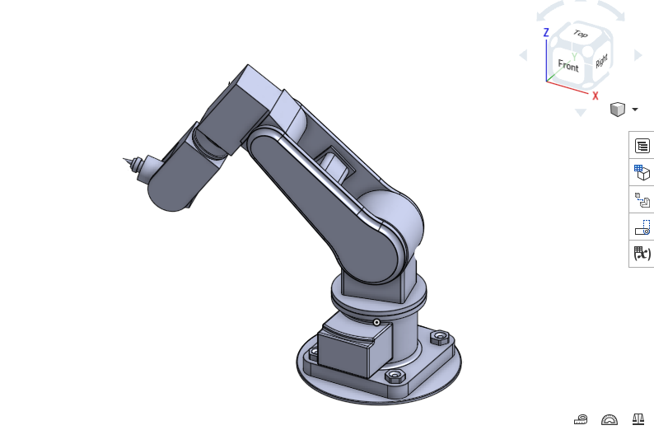
Robot at Home position (MATLAB show(robot) or Onshape drag pose
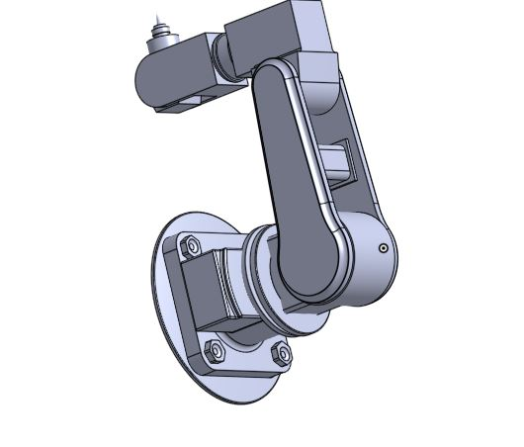

Robot reaching toward the object / target position

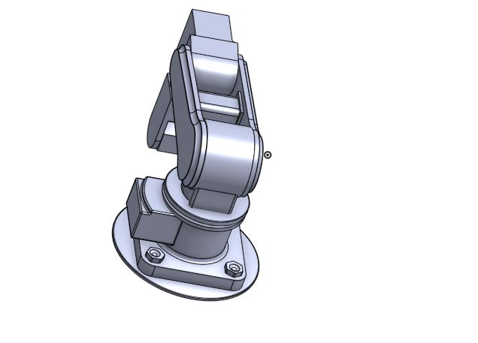

Final position of the robotic arm

8. Basic Robot Motion Description:
Joint 1 (Link 1–Link 2) moves first, lifting/extending Link 2 toward the target region. Joint 2 (Link 2–socle) then adjusts to bring the socle/wrist segment closer to the object. Joint 3 (socle–end-effector) makes the final orientation adjustment so the end-effector tip aligns with the object. Once the end-effector reaches the pick position, it is treated as contacting/picking the object (the CAD model does not include a functional gripper mechanism). The joints then rotate through a new set of angles to carry the object to the place position, after which the robot either holds position or returns toward home.
Step | Robot Action | Joint/Part Involved | Expected Effect
1 | Start from home position | All joints | Robot begins from rest, all angles at 0°
2 | Rotate toward target | Joint 1 (Link 1–Link 2) | Arm swings/extends toward the object
3 | Position end-effector | Joint 2, Joint 3 | Tool reaches and orients toward the working area
4 | Pick/touch target | End-effector (piece 5) | Object is reached / considered picked
5 | Move to final position | Joints 1–3 | Robot completes the placing task

9. MATLAB/Simulink Multibody Preparation:
Two approaches were attempted for bringing the CAD assembly into MATLAB for simulation, since the source file was authored in Onshape rather than SolidWorks (which has a direct Simscape export plugin). Both the process and the issues encountered are documented below, as instructed by the assignment.
Attempt 1 :Simscape Multibody (.slx) export from Onshape
Onshape's Simscape Multibody export was used to generate a .slx file directly. Opening this file's internal structure (the .slx is a ZIP-based package) confirmed the joint wiring shown in Section 6: bodies pice1_base, piece_2_link_1, pice_3_link_2, piece_4_socle and piece_5, connected via a Weld joint (fastened_1) and three Revolute joints (revolute_2, revolute_3, revolute_4).
What worked: the model correctly detected all 5 bodies and all 4 joints (1 fixed + 3 revolute), and mass/inertia properties were embedded numerically for every part.
What failed: on first simulation attempt, MATLAB reported that the Visual geometry files (.stl meshes) referenced by each body's Visual block could not be found, since the mesh files were not bundled alongside the exported .slx.
Reason: the Onshape Simscape exporter stores only a relative file path to the mesh geometry rather than embedding the mesh directly in the .slx package; the corresponding mesh folder was not present on the machine running the simulation.
Correction: rather than continuing to patch file paths individually, a full URDF package (meshes/, launch/, urdf/ folders) was exported from Onshape instead, and re-imported using MATLAB's Robotics System Toolbox, as described in Attempt 2 below.
% Excerpt used to inspect the exported .slx joint wiring
% (performed by unpacking the .slx as a ZIP archive)
% Verified blocks: pice1_base, piece_2_link_1, pice_3_link_2,
% piece_4_socle, piece_5, fastened_1 (Weld), revolute_2/3/4 (Revolute)
Attempt 2: URDF import via Robotics System Toolbox (successful)
A complete URDF package was exported from Onshape and imported directly using importrobot(), which automatically resolved the associated mesh files because the working folder was set to the package root.
clc
clear
close all
cd('<path to package root>\robotic_arm_3_dof_pick_and_place_mechanism_1_snapshot_1');
% Import the real robot from URDF
robot = importrobot('urdf\robotic_arm_3_dof_pick_and_place_mechanism_1_snapshot_1.urdf');
robot.DataFormat = 'row';
figure;
show(robot);
axis equal;
view(-45, 20);
set(gca, 'CameraUpVector', [0 0 1]);
title('Robot Arm - Home Position');
showdetails(robot)
Detected bodies and joints (from showdetails(robot), MATLAB Command Window output):
Idx | Body Name | Joint Name | Joint Type | Parent
1 | pièce1__base | fixed_node_to_root_joint | Fixed | root (0)
2 | piece_2_link_1 | fastened_1 | Fixed | pièce1__base (1)
3 | pièce_3_link_2 | revolute_2 | revolute | piece_2_link_1 (2)
4 | piece_4_socle | revolute_3 | revolute | pièce_3_link_2 (3)
5 | piece_5 | revolute_4 | revolute | piece_4_socle (4)

This result independently confirmed the joint structure identified in Section 6, giving confidence that the reported 3-DOF classification is correct. With DataFormat set to 'row', the robot's configuration vector only includes the 3 movable (revolute) joints: config(1), config(2), config(3), since the fixed joints require no value.
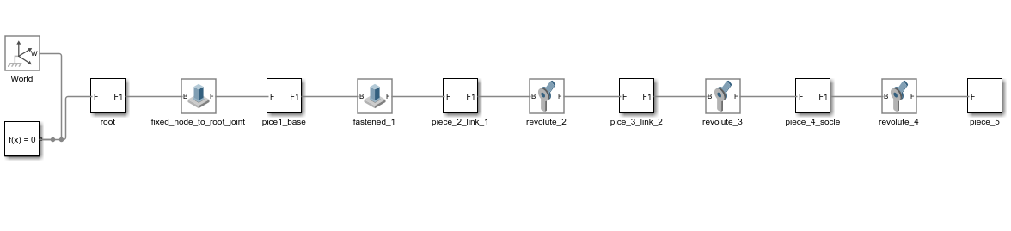
SIMULINK image showing joints and links
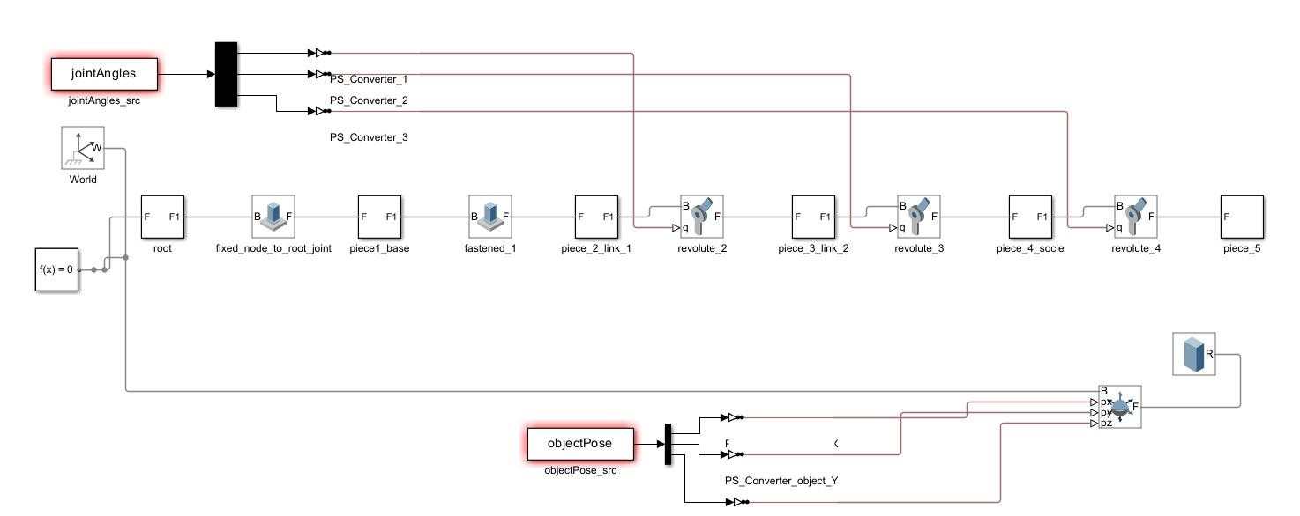
Final Simulink image

10. Robot Motion Demonstration
A 2-second pick-and-place motion was designed across the 3 confirmed revolute joints, sampled at 5 time steps (0, 0.5, 1, 1.5, 2 seconds).
Time | Joint 1 (revolute_2) | Joint 2 (revolute_3) | Joint 3 (revolute_4) | End-Effector State
0.0 s | 0° | 0° | 0° | Home
0.5 s | 20° | 15° | -10° | Moving to object
1.0 s | 35° | 25° | -20° | Pick position
1.5 s | -20° | 30° | -15° | Moving to final position
2.0 s | -30° | 10° | 0° | Release / stop

MATLAB Animation Script
t = [0 0.5 1 1.5 2];
J1 = deg2rad([0 20 35 -20 -30]); % Joint 1 - revolute_2
J2 = deg2rad([0 15 25 30 10]); % Joint 2 - revolute_3
J3 = deg2rad([0 -10 -20 -15 0]); % Joint 3 - revolute_4
figure;
for i = 1:length(t)
config = homeConfiguration(robot);
config(1) = J1(i);
config(2) = J2(i);
config(3) = J3(i);
show(robot, config, 'PreservePlot', false, 'Frames', 'off');
axis equal;
xlim([-1 1]); ylim([-1 1]); zlim([-0.2 1.5]);
view(-45, 20);
set(gca, 'CameraUpVector', [0 0 1]);
title(sprintf('Robot Motion at t = %.1f s', t(i)));
drawnow;
pause(1);
end

Joint Angle Plot
t = [0 0.5 1 1.5 2];
J1 = [0 20 35 -20 -30];
J2 = [0 15 25 30 10];
J3 = [0 -10 -20 -15 0];
figure;
plot(t,J1,'-o', t,J2,'-s', t,J3,'-^','LineWidth',2);
xlabel('Time (s)'); ylabel('Joint Angle (deg)');
legend('Joint 1 (revolute\_2)','Joint 2 (revolute\_3)','Joint 3 (revolute\_4)');
title('Joint Trajectories over 2-second Motion');
grid on;

Joint-angle vs time plot (from MATLAB plot script above):
The images bellow shows how joint angles and time varies
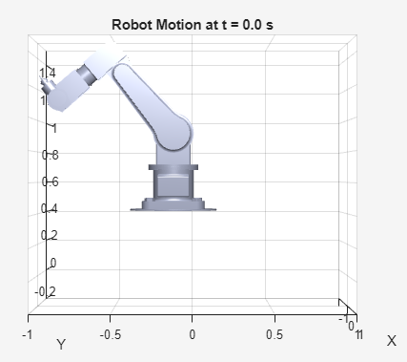
Robot pose at t = 0.0 s (home)
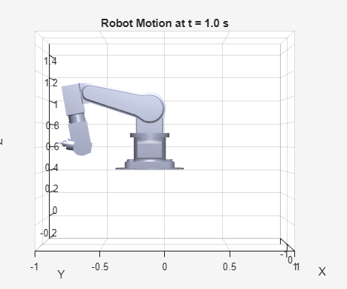
Robot pose at t = 1.0 s (pick position)
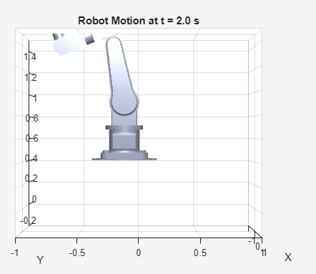
Robot pose at t = 2.0 s (release / final)
During the 2-second motion, the robot begins at rest (home), rotates Joint 1 and Joint 2 to bring the end-effector toward the object, reaches the pick position at t = 1.0 s, then rotates through a new configuration to carry the object toward the place location, ending at t = 2.0 s in the release/stop configuration.
11. Workspace or Reachability Observation:
The workspace was estimated by manually driving each joint through its visible range of motion in Onshape and by summing the approximate link lengths observed in the CAD model. Based on approximate link proportions (base height ≈ 0.10 m, Link 2 ≈ 0.20 m, socle segment ≈ 0.20 m, end-effector length ≈ 0.08 m), the theoretical maximum reach of the end-effector from the base axis is approximately 0.48 m, forming a partial spherical/toroidal region above and to the sides of the base, limited by the base being fixed to Link 1 (no waist rotation).

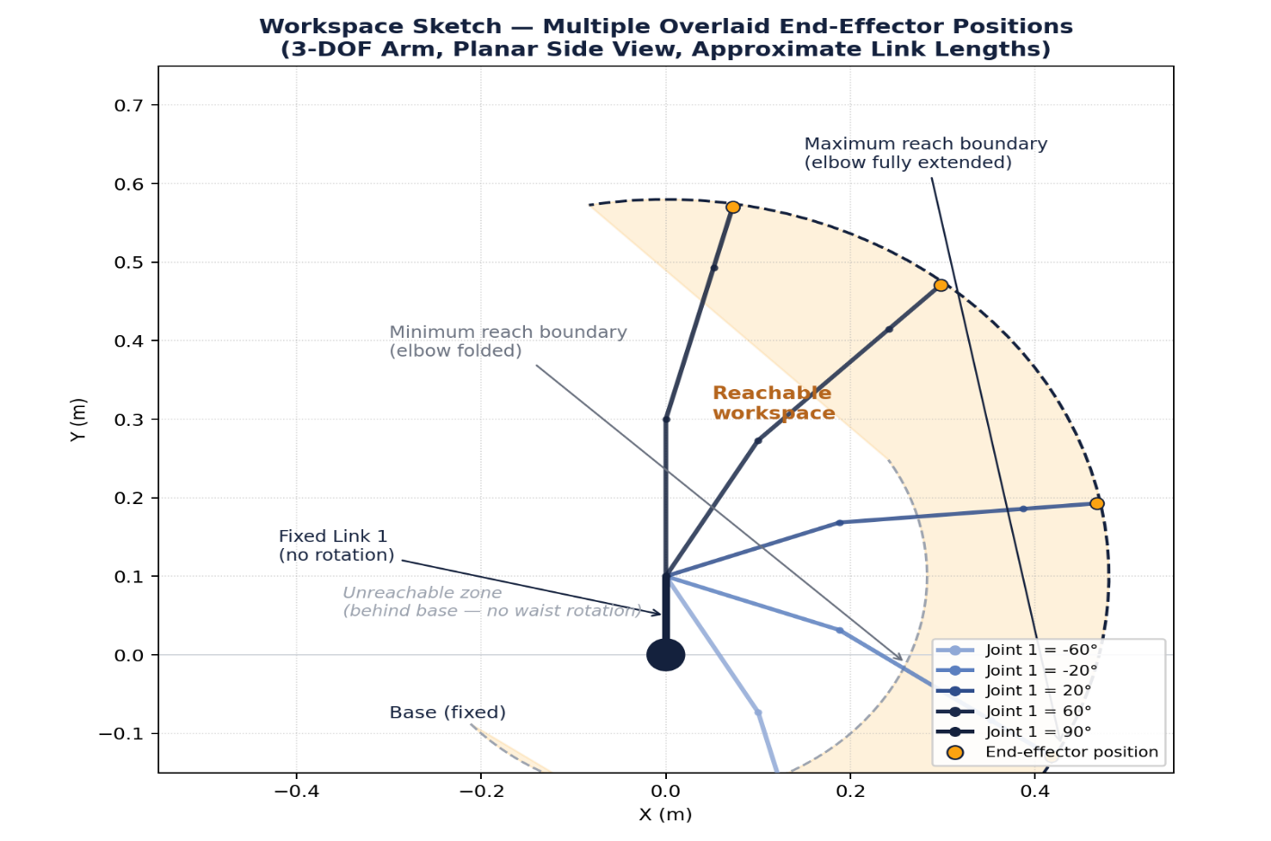
Workspace sketch / multiple overlaid end-effector positions
12. Practical Applications and Limitation:
Applications
- Pick-and-place of small parts in an educational or light industrial setting
- Demonstration and teaching of articulated-arm kinematics
- Small parts handling / sorting where a fixed orientation base is acceptable
Limitations:
- No functional gripper is present in the CAD model — the end-effector is a rigid tip, so 'picking' is represented as contact rather than an actual grasp
- The base is rigidly welded to Link 1, removing a waist (yaw) rotation that most industrial articulated arms have, which restricts the usable workspace to roughly one side of the robot
- The original ZIP file contained no pre-defined mates, so the joint structure had to be reconstructed manually and then cross-verified against the exported Simscape/URDF data — a process that revealed an initial discrepancy (4 vs. 3 DOF) before the correct structure was confirmed
- Visual mesh files were missing from the initial Simscape (.slx) export, requiring a switch to a full URDF package export to obtain a working 3D visualisation
- Link lengths used for the workspace estimate in Section 11 are approximate, not measured to CAD tolerance
- No motor, actuator, or gripper hardware details are visible in the CAD, limiting the realism of a full dynamic (torque-based) simulation
13. Conclusion:
This assignment demonstrated how a downloaded robot CAD assembly initially just a set of unconstrained part files can be interpreted, reconstructed, and verified as a working robotics system. The selected model was confirmed to be a 3-DOF articulated arm consisting of a fixed base–Link 1 connection followed by three sequential revolute joints. This conclusion was reached through two independent methods: manual mate reconstruction in Onshape, and direct inspection of the model's exported Simscape and URDF joint data, which agreed with each other and with the original file's naming. The robot was successfully imported into MATLAB using Robotics System Toolbox and demonstrated performing a 2-second pick-and-place joint trajectory. The exercise highlighted the importance of verifying CAD structure against real constraint/joint data rather than relying on visual inspection or file naming alone.
14. References:
[1] Assignment brief: Robotics Assignment ; CAD-Based Robot Structure Identification and Motion Demonstration.
[2] MathWorks Robotics System Toolbox documentation ; importrobot, rigidBodyTree, showdetails, homeConfiguration, show.
[3] Onshape documentation; Assembly mates, Export (STEP, URDF, Simscape Multibody).
[4] Robot CAD model: robotic-arm-3-dof-pick-and-place-mechanism-1.snapshot.1.zip (source repository as provided in the assignment).

